**Code Design Patterns in Test Automation**

**PREREQUISITES**: project with Selenium WebDriver HW-s (parts 1-3) done.

**MANDATORY:** Implement the following design patterns in your solution from previous module:

* 1. Singleton

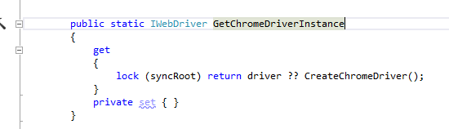

* 1. Factory Method

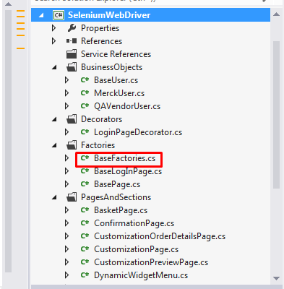

* 1. Decorator

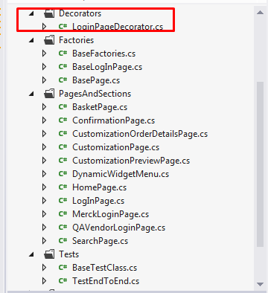

You can use any area of you code to apply the pattern (any code layer – test, service or page object and their combinations).

Implement the pattern in form, which is more convenient for you – there is no strict requirements or restrictions.

You can consult with your mentor about the correct area of applying the pattern as well, but it’s better to do it by yourself.

**OPTIONAL:** You can implement any extra pattern mentioned during the training session (for extra mark) or any other pattern instead of the list above, but discuss it with your mentor.